National University of Computer and Emerging Sciences



Lab 08

COAL

|  |  |
| --- | --- |
| Name | Muhammad Zain |
| Roll No. | 19F-0228 |
| LAB INSTRUCTOR | Mr. Abuzar Ghafari |
| Semester | Fall 2020 |

Task 1

# **Source Code**:

*;Author :Muhammad Zain*

;Task :Task 1

;Name :Multiplication with a constant

include Irvine32.inc

.data

String_Array DWORD 9,8,7,6,5,4,3,2,1

; result_Array DWORD Counter dup(?)

Constant_Num BYTE 5

const_msg BYTE "9*5,8*5,7*5,6*5,5*5,4*5,3*5,2*5,1*5 ",0

resultant_msg BYTE "The Array after Multiplication with 5 ",0

space BYTE " ",0

.code

main proc

mov eax, white + (lightred * 16)

call SetTextColor

mov edx,offset resultant_msg

call writestring

call crlf

cld ;clear directioin flag

mov esi,offset String_Array

mov edi ,esi ;source index to destination index

mov ecx,LENGTHOF String_Array

mov edx,offset const_msg

call writestring

call crlf

L1:

lodsd ;load string

mul Constant_Num

mov edx,offset space

call writestring

call writedec

stosd ;store string

loop L1;

exit

main endp

end main

# **Snip:**

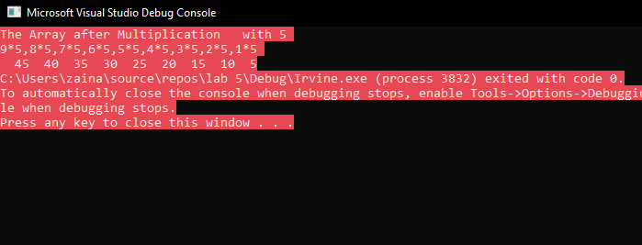

Task 2

# Source Code:

*;Author :Muhammad Zain*

;Task :Task 2

;Name :Search and plus Counter

include Irvine32.inc

.data

msg_1 BYTE "Values of Registers before funtion call ",0

msg_2 BYTE "Values of Registers after funtion call ",0

Target BYTE "123ABC342432",0

Source BYTE "ABC",0

Space BYTE "Value at index = ",0

.code

main proc

mov eax, white + (lightred * 16)

call SetTextColor

mov edx ,offset msg_1

call writestring

call crlf

call dumpregs

call string_find_proc

mov edx, offset msg_2

call writestring

call crlf

call dumpregs

exit

main ENDP

string_find_proc proc uses esi edi ecx

mov esi,OFFSET source

mov edi,OFFSET target

mov al, [esi]

mov ecx,LENGTHOF target

cld ;Clear direction flag

repne scasb ;repeat while not equals

jnz quit

mov eax, LENGTHOF target

sub eax, ecx

mov edx, offset Space

call writestring

call writedec

call crlf

call crlf

quit:

ret

string_find_proc endp

END main

# Snip: